ab - Building a Switch and Router Network

1. Topology

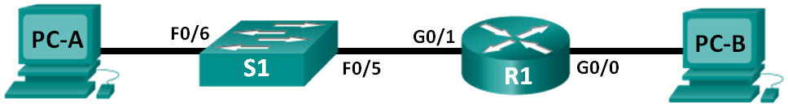

1. Addressing Table

|  |  |  |  |  |
| --- | --- | --- | --- | --- |
| Device | Interface | IP Address | Subnet Mask | Default Gateway |
| R1 | G0/0 | 192.168.1.1 | 255.255.255.0 | N/A |
|  | G0/1 | 192.168.2.1 | 255.255.255.0 | N/A |
| S1 |  |  |  |  |
| PC-A | NIC | 192.168.2.3 | 255.255.255.0 | 192.168.2.1 |
| PC-B | NIC | 192.168.1.3 | 255.255.255.0 | 192.168.1.1 |

1. Set Up Topology and Initialize Devices
   1. Cable the network as shown in the topology.
      1. Attach the devices shown in the topology diagram, and cable, as necessary.
      2. Power on all the devices in the topology.
   2. Initialize and reload the router and switch.

If configuration files were previously saved on the router and switch, initialize and reload these devices back to their basic configurations. For information on how to initialize and reload these devices, refer to Appendix B.

1. Configure Devices and Verify Connectivity

In Part 2, you will set up the network topology and configure basic settings, such as the interface IP addresses, device access, and passwords. Refer to the Topology and Addressing Table at the beginning of this lab for device names and address information.

**Note**: Appendix A provides configuration details for the steps in Part 2. You should attempt to complete Part 2 prior to reviewing this appendix.

* 1. Assign static IP information to the PC interfaces.
     1. Configure the IP address, subnet mask, and default gateway settings on PC-A.
     2. Configure the IP address, subnet mask, and default gateway settings on PC-B.
     3. Ping PC-B from a command prompt window on PC-A.

Why were the pings not successful?

____________________________________________________________________________________

* 1. Configure the router.
     1. Console into the router and enable privileged EXEC mode.

Router>**enable**

Router#

* + 1. Enter configuration mode.

Router# **conf t**

Enter configuration commands, one per line. End with CNTL/Z.

Router(config)#

* + 1. Assign a device name to the router.

Router(config)# **hostname R1**

* + 1. Disable DNS lookup to prevent the router from attempting to translate incorrectly entered commands as though they were host names.

R1(config)# **no ip domain-lookup**

* + 1. Assign **class** as the privileged EXEC encrypted password.

R1(config)#**enable secret class**

* + 1. Assign **cisco** as the console password and enable login.

R1(config)# **line con 0**

R1(config-line)# **password cisco**

R1(config-line)# **login**

R1(config-line)# **exit**

R1(config)#

* + 1. Assign **cisco** as the vty password and enable login.

R1(config)# **line vty 0 4**

R1(config-line)# **password cisco**

R1(config-line)# **login**

R1(config-line)# **exit**

* + 1. Encrypt the clear text passwords.

R1(config)#**service password-encryption**

* + 1. Create a banner that warns anyone accessing the device that unauthorized access is prohibited.

R1(config)# **banner motd #**

Enter TEXT message. End with the character '#'.

**Unauthorized access prohibited!**

**#**

R1(config)#

* + 1. Configure and activate both interfaces on the router.

R1(config)# **int g0/0**

R1(config-if)# **description Connection to PC-B.**

R1(config-if)# **ip address 192.168.1.1 255.255.255.0**

R1(config-if)# **no shut**

R1(config-if)#

R1(config-if)# **int g0/1**

R1(config-if)# **description Connection to S1.**

R1(config-if)# **ip address 192.168.2.1 255.255.255.0**

R1(config-if)# **no shut**

R1(config-if)# **exit**

* + 1. Ping PC-B from a command prompt window on PC-A.

Were the pings successful? Why?

____________________________________________________________________________________

1. Display Device Information

In Part 3, you will use **show** commands to retrieve information from the router and switch.

* 1. Retrieve hardware and software information from the network devices.
     1. Use the **show version** command to answer the following questions about the **Router**.

What is the name of the IOS image that the router is running? Everest

How much DRAM memory does the router have? 419430k bytes

How much NVRAM memory does the router have? 32768k bytes

How much Flash memory does the router have? 3207167k bytes

* + 1. Use the **show version** command to answer the following questions about the **Switch**.

What is the name of the IOS image that the switch is running? C2960-lanbasek9-mz.152-2.E8/c2960-lanbasek9-mz.152-2.E8bin

How much dynamic random access memory (DRAM) does the switch have? 131072k bytes

How much nonvolatile random-access memory (NVRAM) does the switch have? 64k

What is the model number of the switch? WS-C2960+24TC-L

* 1. Display the routing table on the router.

Use the **show ip route** command on the router to answer the following questions.

What code is used in the routing table to indicate a directly connected network? _____

How many route entries are coded with a C code in the routing table? _________

What interface types are associated to the C coded routes?

______________________________________________________________________________________

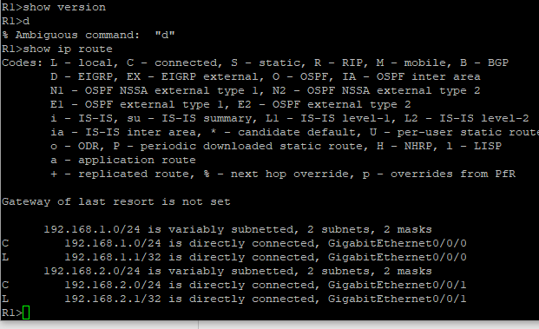

* 1. Display interface information on the router.

Use the **show interface g0/1** to answer the following questions.

What is the operational status of the G0/1 interface? ___________________________________________

Fill in the following:

|  |  |  |
| --- | --- | --- |
| Device | MAC | IP Address |
| PC1 | bcd2.95c2.92d1 | 192.168.2.1/24 |
| PC2 |  |  |
| R1 Gi0/0 |  |  |
| R1 Gi0/1 |  |  |

* 1. Display a summary list of the interfaces on the router and switch.

There are several commands that can be used to verify an interface configuration. One of the most useful of these is the **show ip interface brief** command. The command output displays a summary list of the interfaces on the device and provides immediate feedback to the status of each interface.

* + 1. Enter the **show ip interface brief** command on the **router**.

R1# **show ip interface brief**

Interface IP-Address OK? Method Status Protocol

Embedded-Service-Engine0/0 unassigned YES unset administratively down down

GigabitEthernet0/0 192.168.1.1 YES manual up up

GigabitEthernet0/1 192.168.2.1 YES manual up up

Serial0/0/0 unassigned YES unset administratively down down Serial0/0/1 unassigned YES unset administratively down down

* + 1. Enter the **show ip interface brief** command on the switch.